

Assignment 2:

Sharp Auto Centre

Employee Sales bonus

Jean-Luc Desroches

Tom Tsiliopoulos

Georgian College

Table of Contents

Summary: 3

Design GUI Sketch: 3

Settings GUI Sketch 4

Confirmation GUI Sketch 4

Code Planning 5

Code Design Functions 9

Code Purchase Functions 11

Final Form Design Sample 11

Final Form Settings Sample 12

Final Form Settings Sample 13

Resource Picture Used 13

# Summary:

This application is designed to allow the user to purchase a custom Telsa Model S, allowing them to choose paint colour, battery options, and many other options. The user can also customize the forms font style, as well as its colour theme through the settings tab. Once they have chosen their settings, they may view the final price by pressing the buy button, and then confirming their purchase.

# Design GUI Sketch:

Select the colour group using the radio buttons here

Select specific colour for the car here

Costs are shown for each item on the left

Select the roof option using the radio buttons here

Select the wheel option using the radio buttons here

Select the Battery option using the radio buttons here

Select the interior seating option using the radio buttons here

Output the running subtotal to the user here

Additional options can be chosen here

Click here to view final cost and confirm purchase

Reset all options by pressing this button

This button will set all options to to best value

# Settings GUI Sketch

User can switch between the design tab and thee settings tab

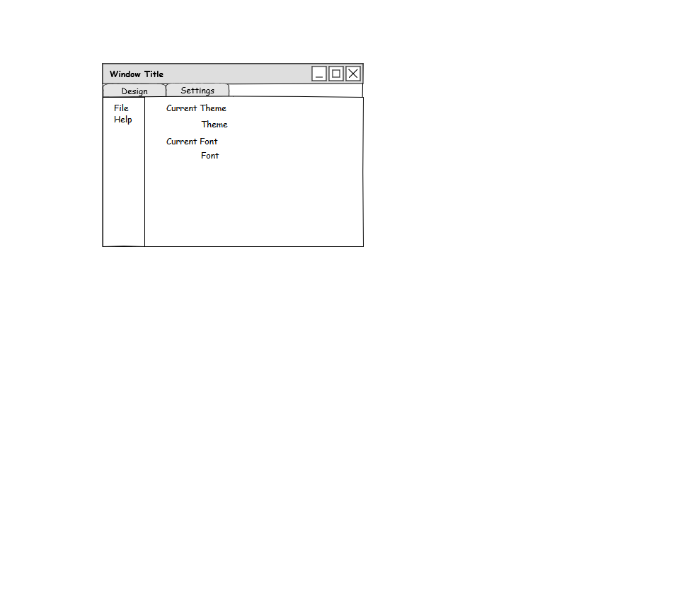

In file the user can change the font of the form, change form themes, as well as exit the form

Currently selected theme and font is displayed here

# Confirmation GUI Sketch

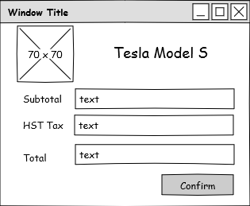

Tesla Motors Logo

Subtotal cost of the car, with options user has selected

How much tax is being applied to the purchase

Final total of the car, after taxes have been applied

# Code Planning

|  |  |
| --- | --- |
| form |  |
| tabMenu | Tab menu allows the user to switch between the design window, and settings window |
| menuStrip | Menu allows the user to exit the form as well as change form settings such as Font and the forms theme |
| colourGroup | Paint colour options are presented via radio button for the user to select which type of paint to use |
| colourOptionBox | After selecting which paint type to use, the user can then select which paint colour they would like their Telsa Model S |
| roofGroup | Roof options are presented via radio buttons for the user to select which type of roof for their car |
| wheelGroup | Wheel options are presented to the user via radio buttons for them to select which wheel type they would like for their car |
| batteryGroup | Battery options are presented to the user via radio buttons which allow them to select which battery they want for their car |
| interiorOptionBox | Interior seating options are presented to the user via radio buttons, which allow them to select what they would like their seats covers made with |
| extraOptionsBox | Various extra add-on options are presented to the user here via check boxes |
|  |  |

|  |  |
| --- | --- |
| teslaSForm | Properties |
| Size | 420,450 |
| AcceptButton | buyButton |
| CackColor | 64,64,64 |
| FormBorderStyle | FixedSingle |
| Icon | Icon Resource File |
| Locked | True |
| MainMenuStrip | menuStrip |
| SizeGripStyle | Hide |
| StartPosition | CenterScreen |
| Text | Sharp Auto Centre |

|  |  |
| --- | --- |
| logoPictureBox | Properties |
| Size | 53, 53 |
| Image | Tesla Motors Logo |
| Location | 26,6 |
| SizeMode | StretchImage |

|  |  |
| --- | --- |
| titleLabel | Properties |
| Size | 53, 53 |
| Font | Microsoft Sans Serif, 18pt |
| Location | 171,18 |
| BackColor | 64,64,64 |

|  |  |
| --- | --- |
| tabMenu | Properties |
| Font | Microsoft Sans Serif, 12pt |
| ItemSize | 58,30 |
| Size | 416,850 |

|  |  |
| --- | --- |
| designTab | Properties |
| BackColor | 64,64,64 |
| AutoScroll | True |
| Font | Microsoft Sans Serif 12pt |
| Text | Design |

|  |  |
| --- | --- |
| colourGroup | Properties |
| BackColor | 64,64,64 |
| Location | 11, 63 |
| Size | 213, 84 |
| Text | Colour Set |

|  |  |
| --- | --- |
| roofGroup | Properties |
| BackColor | 64,64,64 |
| Location | 11, 153 |
| Size | 370,92 |
| Text | Roof Options |

|  |  |
| --- | --- |
| wheelGroup | Properties |
| BackColor | 64,64,64 |
| Location | 11, 251 |
| Size | 370, 100 |
| Text | Wheel Options |

|  |  |
| --- | --- |
| batteryGroup | Properties |
| BackColor | 64,64,64 |
| Location | 11, 358 |
| Size | 370, 118 |
| Text | Interior Options |

|  |  |
| --- | --- |
| interiorOptionBox | Properties |
| BackColor | 64,64,64 |
| Location | 11, 482 |
| Size | 370, 89 |
| Text | Interior Options |

|  |  |
| --- | --- |
| extraOptionsBox | Properties |
| BackColor | 64,64,64 |
| Location | 11, 577 |
| Size | 370, 128 |
| Text | Extras |

|  |  |
| --- | --- |
| themeBox | Properties |
| BackColor | 64,64,64 |
| Location | 56, 6 |
| Size | 349, 67 |
| Text | Current Theme |

|  |  |
| --- | --- |
| fontSelectionBox | Properties |
| BackColor | 64,64,64 |
| Location | 56, 79 |
| Size | 349, 67 |
| Text | Current Font |

|  |  |
| --- | --- |
| logoPictureBox | Properties |
| BackColor | 64,64,64 |
| Location | 8, 7 |
| Size | 77, 77 |
| Image | Tesla Motors Logo |

# Code Design Functions

|  |  |
| --- | --- |
| designForm Functions and Procedures |  |
| PaintButtons_CheckedChanged | Check which paint option has been selected and update costs shown to the user |
| roofButtons_CheckedChanged | Checks which roof option has been selected and updates the costs shown to the user |
| colours | @param selection  Takes 0 or 1 to determine which colour group to return    Returns the colour options based on the selected option, 0 is solid colours, 1 is metallic colours |
| teslaSForm_Load | Sets form size and initialises all cost label settings for the form, as well as setting the default theme to the form |
| calculateOptions | Calculates the total cost of the options based on what has been selected |
| calculateTotal | Calculates the subtotal cost based on the various options the user has selected |
| WheelButton_CheckedChanged | Upon the user clicking any of the wheel options check which wheel has been shosen and update the costs appropriately |
| BatteryButton_CheckedChanged | On click event of any of the battery options, check which battery the user has selected and update the costs |
| highPowerBox_CheckedChanged | Check if the high power option has been selected, update costs for the user |
| techBox_CheckedChanged | Check if the tech upgrade option has been selected, update costs for the user |
| smartSuspensionBox_CheckedChanged | Check if the smart suspension option has been selected, update costs for the user |
| fogBox_CheckedChanged | Check if the fog light option has been selected, update costs for the user |
| maximizeButton_Click | On click event select all of the optimum, parts and options for the car and update all of the costs appropriately using the functions for all of the options |
| resetButton_Click | Reset all options to default, and update costs accordingly |
| franklinGothic12ptToolStripMenuItem_Click | Set fonts on the form to Franklin Gothic |
| microsoftSansSerif12ptToolStripMenuItem_Click | Set fonts on the form to Microsoft Sans Serif |
| segoeUI12ptToolStripMenuItem_Click | Set fonts on the form to Segoe UI Black |
| changeFont | @param fontFamilyName  Font object of font to change interfaces to  Changes the fonts of the form to the font passed into the function |
| changeFontColor | @param fontColor  Color object to be set for text  @param x  dummy Object to be able to call the button functions  @param y  dummy EventArgs to be able to call the button functions  Changes the font colours used througout the program to the specified Color object |
| darkUIToolStripMenuItem_Click | Sets forms theme to the dark theme |
| lightUIToolStripMenuItem_Click | Sets forms theme to the light theme |
| checkThemeLabel | Set the label text for the current theme in the settings tab, to the currently selected theme |
| checkFontLabel | Set the label text for the current font in the settings tab, to the currently selected font |
| changeColors | change the form and tab interface background colour to the specified colour |
| buyButton_Click | Opens a new form window to display the subtotal, tax, and final total to the user |
| helpToolStripMenuItem_Click | Display some helpful information on how to use the form to the user |
| exitToolStripMenuItem_Click | On selecting the exit option either through click, or through shortcut key, exit the program |
| teslaSForm_Close | Catch closing event and ensure application fully exits |

# Code Purchase Functions

|  |  |
| --- | --- |
| purchaseForm Functions and Procedures |  |
| buyButton_Click | When the user cliccks the confirm button show a message box congratulating the user on their new purchase and close out the program |
| purchaseForm_Close | Catches closing event and close hidden form as well as current form |
| purchaseForm_Activate | When the form activates calculate the subtotal |

# Final Form Design Sample

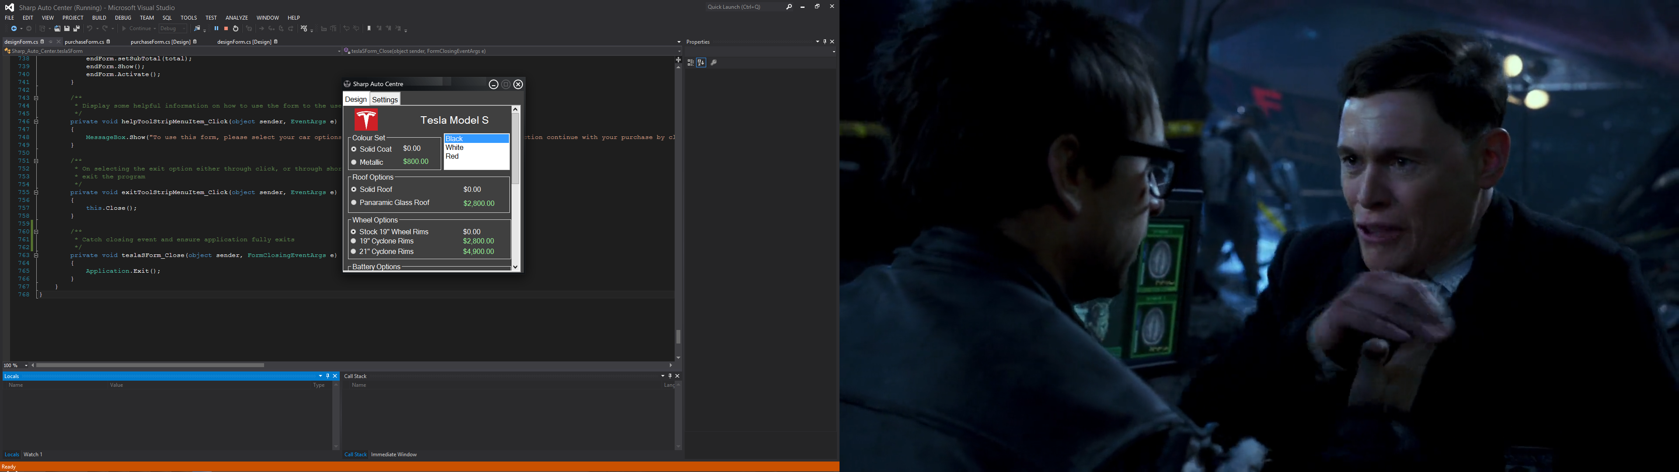

# Final Form Settings Sample

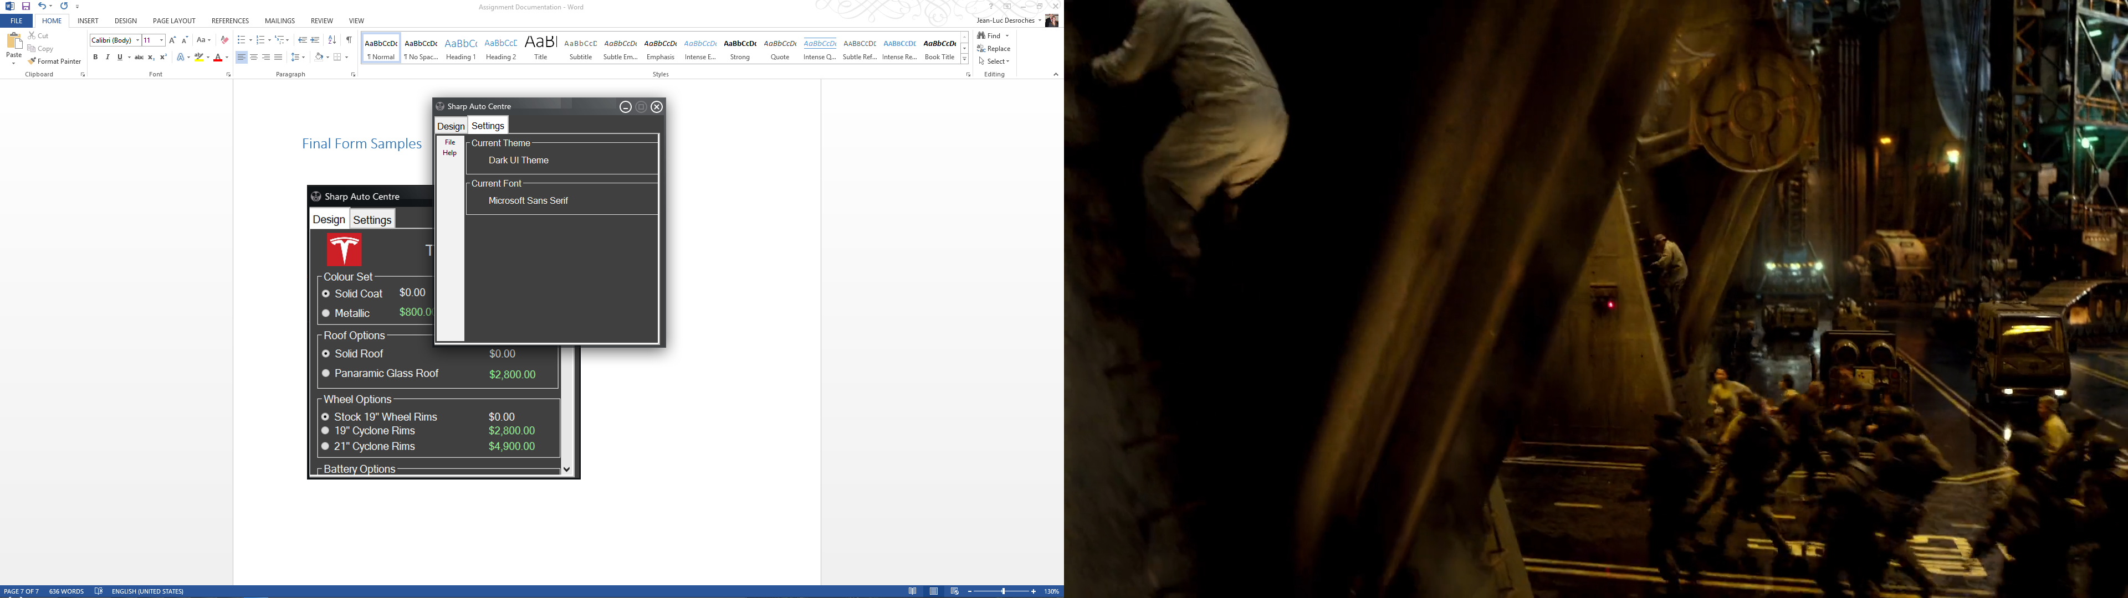

# Final Form Settings Sample

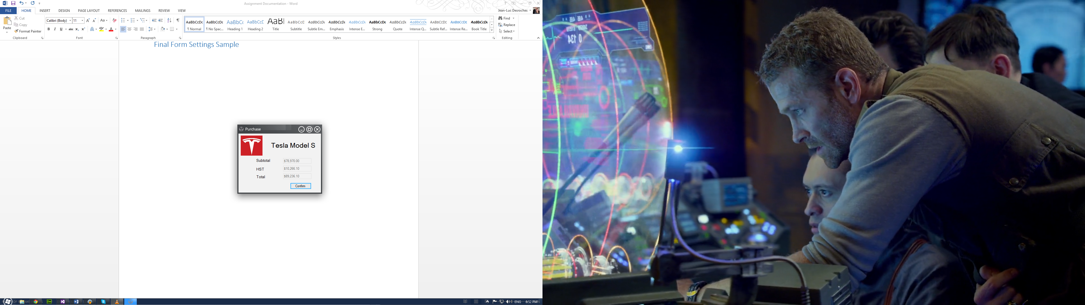

# Resource Picture Used

